Summations on A Square Matrix

Given the following square matrix stored in a variable Matrix, let’s print out the sum of each row, column, and diagonal.

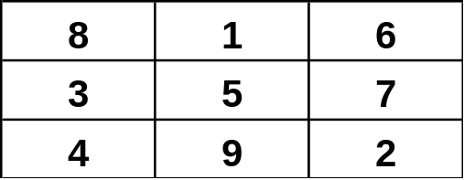

// Printing the sum of each of our rows
for (int i = 0; i < Matrix.length; i++)
{
int hsum = 0;
for (int j = 0; j < Matrix[0].length; j++)
hsum += Matrix[i][j];
System.out.println(hsum);
}

// Printing the sum of each of our columns
for (int j = 0; j < Matrix[0].length; j++)
{
int vsum = 0;
for (int i = 0; i < Matrix.length; i++)
vsum += Matrix[i][j];
System.out.println(vsum);
}

// Printing diagonal sum from Top Left to Bottom Right
int dsum1 = 0;
for (int i = 0; i < Matrix.length; i++)
dsum1 += Matrix[i][i];
System.out.println(dsum1);

// Printing diagonal sum from Top Right to Bottom Left
int dsum2 = 0;
for (int i = 0; i < Matrix.length; i++)
dsum2 += Matrix[i][Matrix.length-i-1];
System.out.println(dsum2);

